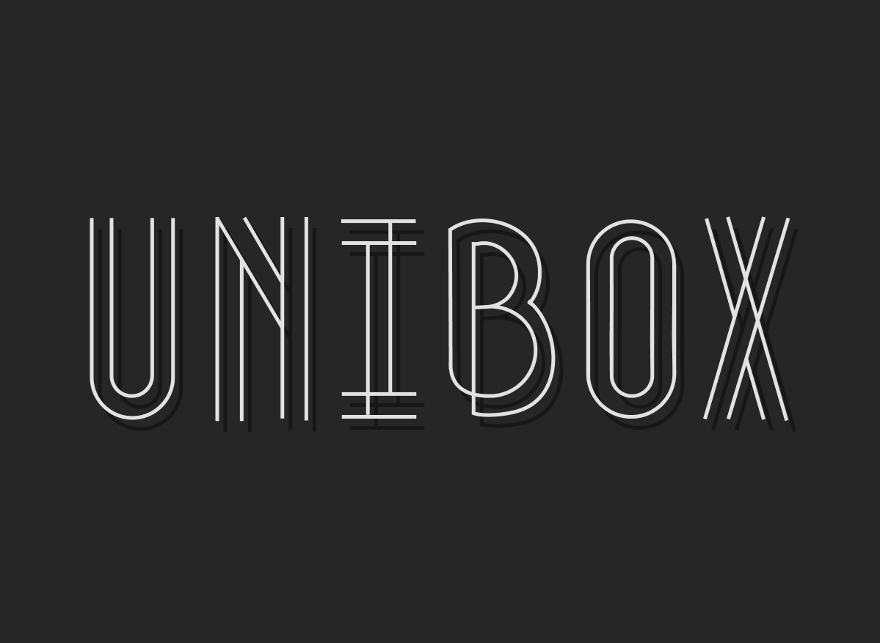

**UniBox**

Contents

Project Description 2

Team Information 2

Project Information 2

Technologies used 2

Ways of Realization 3

Work Plan 4

# Project Description

* *Sandbox for solar system where you can experiment with planets.*
* *The project was build using “raylib” and C++.*

# Team Information

|  |  |  |
| --- | --- | --- |
| № | Name | Role |
| 1 | Luchezar Rashkov | Scrum Trainer |
| 2 | Daniel Kostadinov | Devoloper |
| 3 | Aleksandar Lalev | Devoloper |
| 4 | Ivelin Voynov | Devoloper |

# Project Information

|  |  |
| --- | --- |
| № | Information |
| 1 | **Description**  The project is about tetsting different function in solar system sandbox where you can add or remove planet, change speed or change direction. |
| 2 | **Installation**  To install the project, you can open our GitHub repository and follow the instruction in the README.md file or via our website. |
| 3 | **Communication**  For communicate we used Teams. Which made it easy to share file and text messages. |

# Technologies used

|  |  |  |
| --- | --- | --- |
| № | Technologies | Usage |
| 1 | Visual Studio 2022 | As out IDE |
| 2 | GitHub and Git | For collaboration |
| 3 | C++ | As programming language |
| 4 | Raylib | As a graphical library |
| 5 | Word | For the documentation |
| 6 | PowerPoint | For the presentation |
| 7 | Teams | For communication |
| 8 | Doxygen | For the code documentation |
| 9 | Figma | For the design and logo |

# Ways of Realization

|  |  |  |
| --- | --- | --- |
| № | Issue | Solution |
| 1 | **Task Distribution** | When we distributed the tasks, we took in consideration the skills of each member and where he could be most productive.  For each task we made a GitHub issue which helped us to stay in track and made it easy for each member to see his tasks. |
| 2 | **Task Completion** | There were team meetings almost every day where we discussed problem and the overall state of the project.  Each member worked in a convenient for him time. When he was ready with his part of the project, he committed it to GitHub and closed the respective issue. This made it easy to track the progress of the project. |

# Work Plan

|  |  |
| --- | --- |
| № | Task Description |
| 1 | **Make the design**  The scrum trianer made our design in figma where the developers gets element. |
| 2 | **Make the start menu**  Developers start creating the project by made the start menu where there are two buttons for resume and exit. |
| 3 | **Draw the orbit**  The orbit was drown as first we found the formula which calculate them in NASA site. After that we found a way to implement it in c++ code |
| 4 | **Add planets**  After we drown the orbits it was time to paste the planets and center them. |
| 5 | **Make the planets rotate**  We made the planets move both around their orbits and around the sun. |
| 6 | **Add change direction function**  First function change direction of planets from right to left to left ot right. |
| 7 | **Add change speed function**  This button has 3 stages of speed, from slower to faster. |
| 8 | **Add remove planet function**  This function remove planet you choose. |
| 9 | **Add add planet funtion**  The last but not least is add button where you can add planet in each orbit. |
| 10 | **Add stats tab**  Add tab which show information about every planet. |